Project Report: California House Price Prediction

Course/Task: AI & ML Project Task 1
Submitted By: [Your Name]
Date: May 2026
1. Project Objective
The objective of this project is to build and evaluate an end-to-end Machine Learning workflow using a Linear Regression model. Using the benchmark California Housing dataset, the model was trained to analyze regional characteristics—such as neighborhood income, population, and house age—to forecast median house values.
2. Exploratory Data Analysis (EDA)
Before training the model, the dataset was explored to understand its characteristics:
- Data Completeness: The dataset was checked for missing values and found to be entirely complete, requiring no missing-data imputation.
- Feature Correlation: Data exploration revealed that Median Income (MedInc) has a powerful positive linear correlation with the target variable, Median House Value (MedHouseVal). This indicates that regional income levels are the strongest predictor of property values.
3. Model Performance & Evaluation
The dataset was split into 80% for training the model and 20% for testing its accuracy. The trained Linear Regression model achieved the following performance metrics on the test data:
- Mean Absolute Error (MAE): 0.533 On average, the model's predictions deviate from actual house values by approximately 0.533 units.
- Root Mean Squared Error (RMSE): 0.746 This measures the standard deviation of residuals, showing how closely the data clusters around the line of best fit.
- $R^2$ Score (Coefficient of Determination): 0.576 This confirms that our linear model successfully accounts for 57.6% of the variance in California housing prices based on the provided inputs.

4.Visual Findings
The actual versus predicted price scatter plot demonstrates a clear, positive linear trend that closely aligns with the red baseline reference line.
However, a distinct horizontal/vertical line of data points accumulates at the value of 5.0. This indicates that the original dataset places a cap on maximum house values at $500,000, creating an artificial boundary limit that restricts the model's linear prediction accuracy at higher pricing tiers.
5.Proposed Future Improvements
To further improve model accuracy and build a more robust portfolio project, the following next steps are recommended:
- Utilize Advanced Non-Linear Algorithms: Because linear regression assumes a strictly straight-line relationship, transitioning to tree-based ensemble models like Random Forests or Gradient Boosting (XGBoost) would better capture complex geographical and non-linear interactions.
- Handle Dataset Artifacts (Outlier Filtering): Removing or separating properties affected by the artificial $500,000 upper limit cap would prevent the model from skewing its predictions near the maximum boundary.
- Feature Engineering: Creating new interaction columns—such as calculating the ratio of rooms per household—could provide richer structural context to improve the algorithm's predictions.

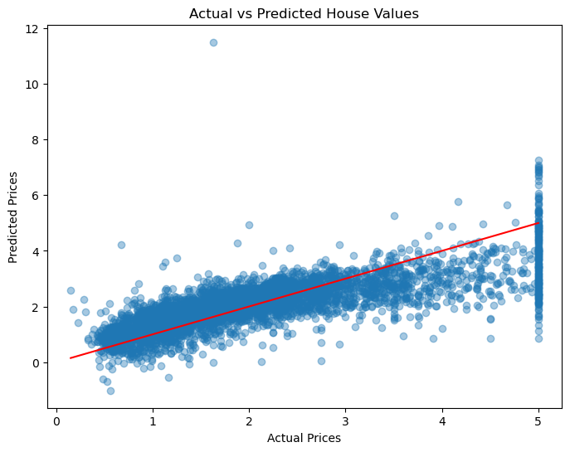
5. Proposed Future Improvements
* Model Serialization: The trained Linear Regression model was successfully saved as a binary file using Python’s pickle library (housing_model.pkl).
* Interactive User Interface: A lightweight web application was developed using Streamlit (app.py). This interface allows end-users to input custom real estate metrics—such as average rooms and neighborhood median income—and receive real-time property value predictions instantly from the backend model.
